**Commend Set Customizer**

* Open Command prompt
* Navigate to your favourite folder
* Ex: C:\Jenkins\SPFx\Nodejs\SPFx\extension
* Create new folder for app customizer
* Ex: listViewCommandSetEx1
* Create spfx solution >yo @microsoft/sharepoint

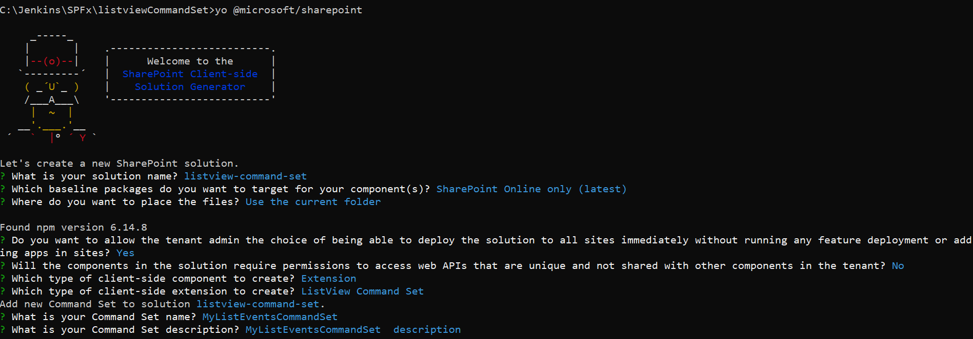

Go to code .

Then open MyListEventsCommandSetCommandSet.ts file

Replace onListViewUpdated method

const GetItemButton: Command = this.tryGetCommand('GetItemButton');

    const GetItemsCommand: Command = this.tryGetCommand('MultipleItemsButton');

    const AlertMessageCommand: Command = this.tryGetCommand('AlertMessageButton');

    if (GetItemButton) {

      GetItemButton.visible = event.selectedRows.length === 1;

    }

    if(GetItemsCommand)

    {

      GetItemsCommand.visible = event.selectedRows.length > 0;

    }

    if(AlertMessageCommand)

    {

      AlertMessageCommand.visible = event.selectedRows.length === 0;

    }

Then update/replace Execute method

|  |
| --- |
| let title = ""; |
|  | switch (event.itemId) { |
|  | case 'GetItemButton': |
|  | Dialog.alert(`${event.selectedRows[0].getValueByName("Title")}`); |
|  | break; |
|  | case 'AlertMessageButton': |
|  | Dialog.alert(`No Item Selected`); |
|  | break; |
|  | case 'MultipleItemsButton': |
|  | this.multipleitemsevent(event); |
|  | break; |
|  | case 'DeleteButton': |
|  | Dialog.prompt(`Please enter the list name to move:`).then((value:string)=> |
|  | { |
|  | title = value; |
|  | this.sendvalue(title,event); |
|  | } |
|  | ); |
|  |  |
|  | break; |
|  | default: |
|  | throw new Error('Unknown command'); |
|  | } |

Then add two more methods

|  |  |
| --- | --- |
| private sendvalue(title:string,event:IListViewCommandSetExecuteEventParameters) | |
|  | | { | |
|  | | let selectedtitle = event.selectedRows[0].getValueByName("Title"); | |
|  | | Dialog.alert(title + "|" + selectedtitle); | |
|  | | } | |
|  | |  | |
|  | | private multipleitemsevent(event:IListViewCommandSetExecuteEventParameters) | |
|  | | { | |
|  | | let title = ""; | |
|  | | let eventdetails =""; | |
|  | | for(var i=0;i<event.selectedRows.length;i++) | |
|  | | { | |
|  | | title += " " + event.selectedRows[i].getValueByName("Title") + " "; | |
|  | | } | |
|  | | Dialog.alert(`${title}`); | |
|  | | } | |

Then update the **MyListEventsCommandSetCommandSet.manifest.json** file items section

"items": {

        "GetItemButton": {

            "title": { "default": "Get Item" },

            "iconImageUrl": "icons/request.png",

            "type": "command"

        },

        "AlertMessageButton": {

            "title": { "default": "No Items Selected" },

            "iconImageUrl": "icons/cancel.png",

            "type": "command"

        },

        "MultipleItemsButton": {

            "title": { "default": "Multiple Items" },

            "iconImageUrl": "icons/cancel.png",

            "type": "command"

        },

        "DeleteButton": {

            "title": { "default": "My Delete Button" },

            "iconImageUrl": "icons/cancel.png",

            "type": "command"

        }

    }

Gulp serve and test it